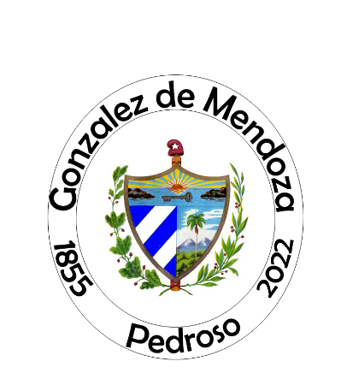
2022 Reunion
Pedroso
González de Mendoza
Payment and Donation Form

Head of Household Contact Information:
Name:
Address:
City: __________ State:_______ Zip______
Phone No.: ________________ Email:_______________________

TICKET COSTS FOR ALL EVENTS: Early Registration: (Before June 1, 2022*)
Adults 18+ | Preteen/teens 11 to 17 | Kids 3 to 10 | Babies 0 - 2
$145.00 | $85.00 | $65.00 | FREE
*Early registration pricing has ended. ** Under 2 years old are free.
NOTICE: Donations are needed to fully fund the event. The rates have been reduced to enable the attendance of all families. Those who can help out are kindly asked to support this family event.
Please Complete This Form and Include with Your Payment. Use the back of the form for additional space.
 | Last Name | First Name |  | Family No.  (Add S if Spouse or  Significant Other) | Adult (A) Teen (T) Kid (K) or Babies (B) | Amount ($)  See Above for Rates
1
2
3
4
5
6
7
8
 |  |  | Total from additional names on back:
 |  |  | Additional Donation $:
 |  |  | Total Check Amount $:
See website for schedule of events
Make Checks Payable to: Mendoza Family Reunion
Please send payment and form to: 631 Velarde Ave.
Coral Gables, FL 33134

For Committee Use Only: Received by: Check No.:
Tickets No.: Tickets Sent On:
www.gonzalezdemendoza.com

